Welcome to the OPSWAT Academy Fundamentals of Critical Infrastructure Protection (CIP) course. You must complete this training before you can begin any of the course programs. These certifications are designed for both seasoned and aspiring cybersecurity professionals alike when approaching the challenges in protecting critical infrastructure networks. But what exactly is critical infrastructure? Well, from a cybersecurity standpoint, the simple answer is "anything worth protecting." Critical infrastructure networks underpin our businesses, economic security, and our public health and safety. Depending on who you ask, the exact definition of critical infrastructure can vary, but they all share a common need- To be secured from bad actors and harmful influences. OPSWAT Academy approaches solutions to this need with best practices and strategies used today on the most important of critical networks - Chemical, Welcome to the OPSWAT Academy Fundamentals of Critical Infrastructure Protection (CIP) course. You must complete this training before you can begin any of the course programs. These certifications are designed for both seasoned and aspiring cybersecurity professionals alike when approaching the challenges in protecting critical infrastructure networks. But what exactly is critical infrastructure? Well, from a cybersecurity standpoint, the simple answer is "anything worth protecting." Critical infrastructure networks underpin our businesses, economic security, and our public health and safety. Depending on who you ask, the exact definition of critical infrastructure can vary, but they all share a common need- To be secured from bad actors and harmful influences. OPSWAT Academy approaches solutions to this need with best practices and strategies used today on the most important of critical networks - Chemical, Transportation, Nuclear, and more. By approaching the challenges within the cybersecurity landscape with the mindset of Critical Infrastructure Protection, we can apply tried-and-true security techniques to not only officially defined critical networks, but also to anything that needs to be protected.
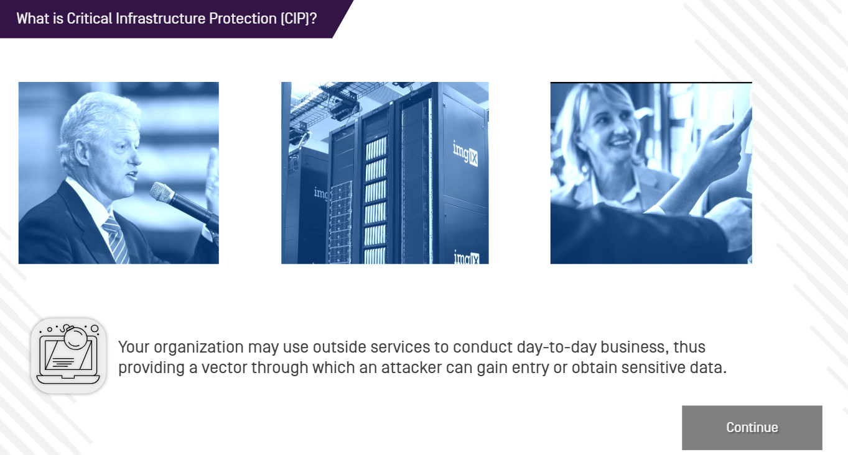

When the term critical infrastructure was first established the facilities and networks driving them operated in isolation, but today the demand for goods and services from local and global populations requires more complexity and interconnectivity than ever before. As communications and connections are established across sectors and the global Internet at large, more vulnerabilities and opportunities for hackers arise. Attacks on critical infrastructure aren't just theory and we have seen many instances of this in recent years.

• In 2013, Iranian hackers breached the Bowman Avenue Dam in New York and gained control of the floodgates.
• 2016 an attack on an Ukrainian power facility left 700,000 individuals, approximately half the population of the Ivano-Frankivsk region, without power in mid- December.
• The Triton malware attack in 2017 was first seen in a Saudi petrochemical plant, allowing the hackers to take over the plant's safety instrument systems (SIS) which prevents release and ignition of toxic and combustible gases.
• In 2021 the Colonial Oil Pipeline was the target of a ransomware attack leading upwards of 45% of the United states East Coast gas, diesel, and jet fuel supplies offline. Leaving over 10,000 gas stations without fuel for several days.
Critical infrastructure is the backbone behind the modern day way of life. But without the means to properly secure these environments, attacks from hackers could leave us all without power, goods, and services. Damages to critical infrastructure affect more than just our creature comforts and can lead to loss of life, property, and financial stability. Critical Infrastructure Protection [CIP) is the practice of ensuring critical networks remain secure. CIP encompasses many aspects of security from physical, to electronic. While the scope of meeting CIP requirements has many considerations, the core of this training program will focus on the cybersecurity aspect of CIP practices. Namely, the various courses will cover three main topics. Malware Mitigation, Device Compliance, and Access control.
That completes this training on the fundamentals of CIP. In this course you learned about the fundamentals of Critical Infrastructure Protection and how to navigate the OPSWAT Academy. Before you go, we'd like you to keep some key takeaways from this training in mind.
• First, the US federal government identified 16 critical infrastructure sectors covering a broad range of critical networks in use today.
• The OPSWAT Academy covers the knowledge and skills required to protect critical infrastructure with best practices and strategies used today on the most important of critical networks.

